Nom : ______________________________ /25 Date : ______________________________

/4 1.

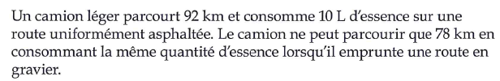

(1)

(1)

(2)

/3 2.



(1)

(2)

/3 3.



(1)

(1)

(1)

/5 4.



/5 5.



(4)

(1)

/5 6.



(4)

(1)